‘There’s no medicine like a dog’: Ex-soldier who trains shelter dogs to become veterans’ companions to be honored on Memorial Day in Maryland – Baltimore Sun
Baltimore Sun
MARYLAND
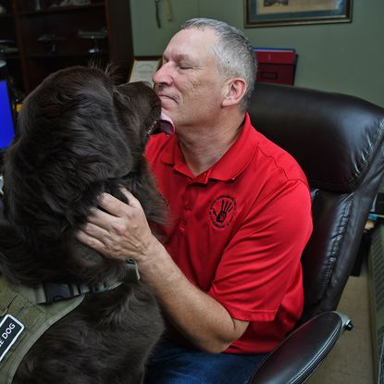

‘There’s no medicine like a dog’: Ex-soldier who trains shelter dogs to become veterans’ companions to be honored on Memorial Day in Maryland
By Barbara Haddock Taylor
Baltimore Sun
•
May 27, 2022 at 6:00 am
Chris Hardy remembers the moment he realized that dogs could change lives. But he has to take a deep breath and work to hold back tears to tell the story.
Hardy, a dog trainer for the U.S. Defense Department in Afghanistan in 2006, was making a routine trip to a field hospital to pick up supplies, along with his dog, Dirk. A nurse was holding a badly injured baby; the infant was burned on her face, neck and body. She suddenly reached out to pet Dirk, her face lighting up with a smile.
Hardy was told later that until that moment, the child had stoically endured treatment, never showing emotion.
Her interaction with Dirk in that brief moment prompted a new connection in her life — and in Hardy’s. He and Dirk returned several times and were asked by hospital personnel if they could start visiting some of their military patients. The experiences “really got me,” he said.
Hardy, an Eastern Shore native who served 11 years in the 82nd Airborne Division, returned home from that and several other deployments with powerful memories and, unfortunately, post-traumatic stress disorder. Remembering the healing power of Dirk, he decided to help fellow injured vets by training service dogs for them.
Now the executive director at U.S. Kennels Inc. in Salisbury, Hardy will take part Monday in the 55th annual Memorial Day ceremony at Dulaney Valley Memorial Gardens in Timonium, where he will be honored with a plaque and a donation to his organization.
“It is our tradition to recognize Maryland organizations and institutions that support our veterans and underscore the true meaning of Memorial Day,” Jack Mitchell, president of Dulaney Valley Memorial Gardens, said in a statement.
In 2017, Hardy and his wife, Mirela, started the nonprofit U.S. Kennels. They rescue dogs from shelters and match them with veterans who need help from a devoted companion. They provide a year of training for veterans and their dogs at their facility, along with food, veterinary care and all the supplies they need, at no charge to the veterans.
The organization has matched around 50 veterans with canine companions, and they have a waiting list for more.
Sam Landis of Greenwood, Delaware, an Army veteran who has PTSD, has trained since August at U.S. Kennels with her mixed-breed dog, Bodhi, who she jokes was a “streetwalker” that ended up at the Wicomico County Humane Society shelter.
The dog keeps a protective bubble around her, she says, and “gets me to a better space.” He can predict her panic attacks and places his paws on her lap for gentle compression if she doesn’t feel well. Like a guardian angel, he never leaves her side. With help from Bodhi, Landis said, her world is expanding and becoming a less frightening place.
Danray Atkinson, a volunteer and lead trainer for U.S. Kennels, was one of its first graduates. He retired from the Army in 2014 after 25 years and five combat tours in Iraq and Afghanistan. His dog, Gus, is trained to provide comfort and stability during the panic attacks and seizures that Atkinson has as a result of PTSD.
Relying on Gus is “like having a battle buddy with you all the time; he’s always got your back. This program has literally saved my life,” Atkinson says.
In return, helping someone in need is the way he gets paid, he said. “That’s all I need.”
Monday’s ceremony at Dulaney Valley will honor service members with ties to Maryland who have died during the past year, as well as all members of the military killed in the line of duty and people killed in the Sept. 11 terrorist attacks.
Those who will be specifically recognized include U.S. Navy Hospital Corpsman 1st Class Sarah F. Burns of Severna Park, U.S. Air Force Airman 1st Class Dewayne A. Stevens of Chester in Queen Anne’s County, and Navy Lt. j.g. Aaron P. Fowler of Oklahoma, a 2018 graduate of the Naval Academy in Annapolis. Burns was among five crew members killed in August in a helicopter crash during a training mission off San Diego. Stevens died in March at Nellis Air Force Base in Nevada, while Fowler died in April during training at Marine Corps Base Hawaii.
Hardy’s faithful companion, a 3-year-old Newfoundland named Brody, will accompany him to Monday’s event.
“There’s no medicine like a dog. They save lives like you wouldn’t believe,” he said.

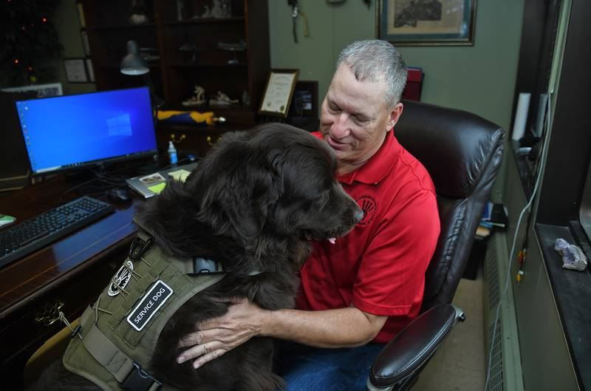
Chris Hardy works at his desk with his service dog, Brody. Hardy, who served in the U.S. Army for 11 years, is the founder of U.S. Kennels Inc., a nonprofit organization that rescues dogs from shelters and trains them to become service dogs for veterans. Brody, a 3-year-old Newfoundland, is always by his side and helps him cope with PTSD. (Barbara Haddock Taylor/Baltimore Sun)

) 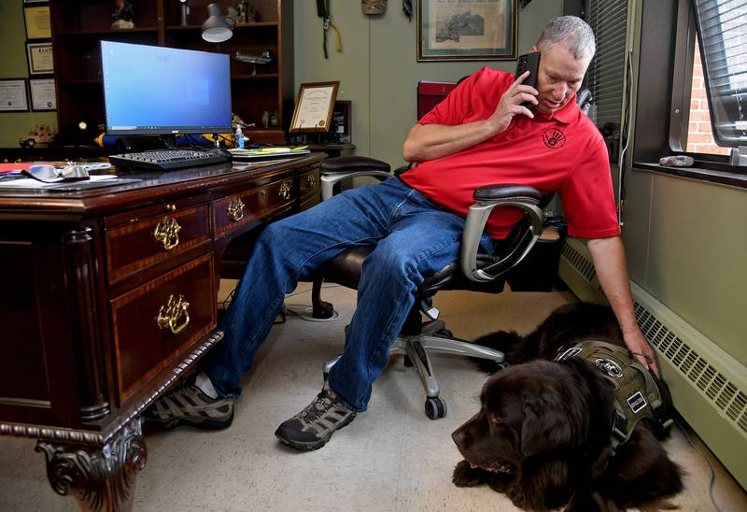
Chris Hardy works at his desk, along with his service dog, Brody. Hardy, a U.S. Army veteran of 11 years, is founder of U.S. Kennels Inc. (Barbara Haddock Taylor/Baltimore Sun)

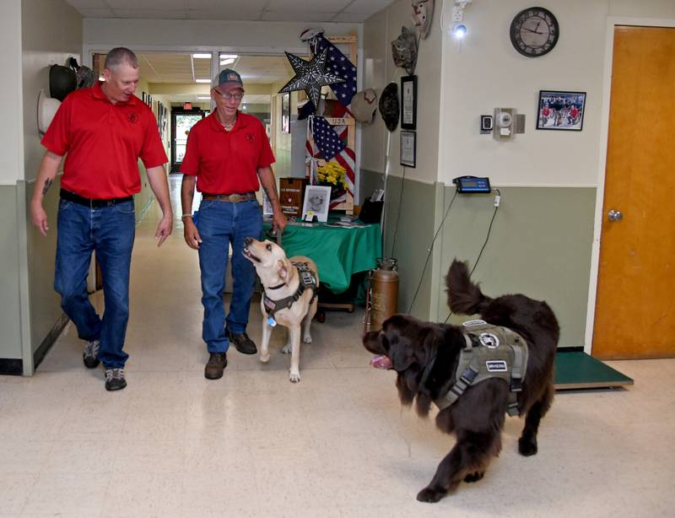

Chris Hardy, left, and Danray Atkinson, right, both U.S. Army veterans, walk with their service dogs Gus, left, and Brody, right, at U.S. Kennels Inc. Hardy will be honored at the annual Memorial Day service at Dulaney Valley Memorial Gardens this year. (Barbara Haddock Taylor/Baltimore Sun)

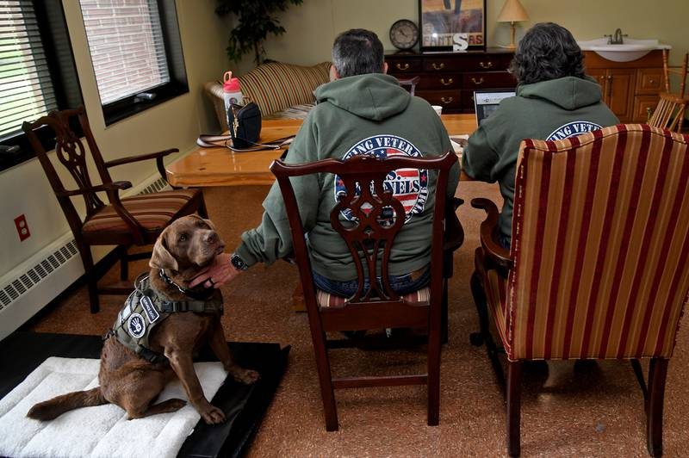
Sam Landis, left, pets her service dog, Bodhi, as she and her wife, Susanne Landis, right, work as volunteers on the newsletter at U.S. Kennels Inc. Sam Landis, an Army veteran who has PTSD, has worked with Bodhi since August and says he has changed her life for the better. (Barbara Haddock Taylor/Baltimore Sun)
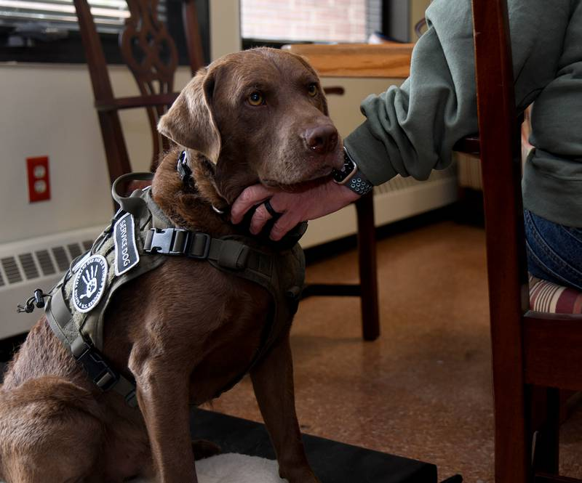 Bodhi, a service dog at U.S. Kennels Inc., gets a reassuring pat from his owner, Army veteran Sam Landis, as she works on the organization's newsletter. Bodhi was found wandering the streets of Salisbury and was taken to the Wicomico County Humane Society shelter, where he was found and adopted by U.S. Kennels. (Barbara Haddock Taylor/Baltimore Sun)
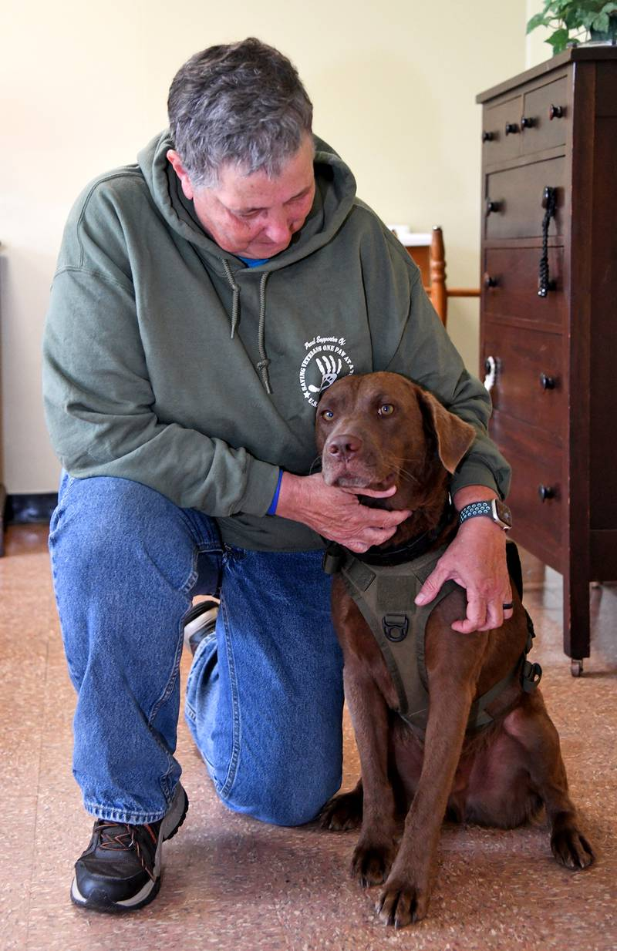
Sam Landis, an Army veteran, with her service dog, Bodhi, at U.S. Kennels Inc. He has been working with Landis, who has PTSD, since August. (Barbara Haddock Taylor/Baltimore Sun)
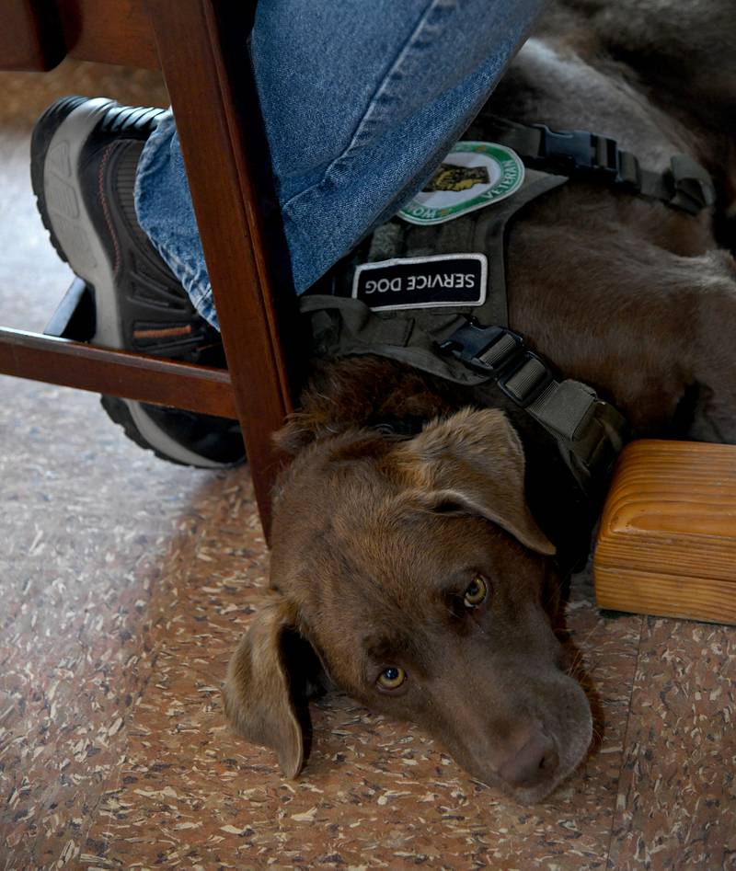
Bodhi, a service dog for Army veteran Sam Landis, relaxes at her feet. They are graduates of U.S. Kennels Inc., a nonprofit organization that rescues dogs from shelters and trains them to become service dogs for veterans. Landis says that Bodhi has changed her life for the better and never leaves her side. (Barbara Haddock Taylor/Baltimore Sun)

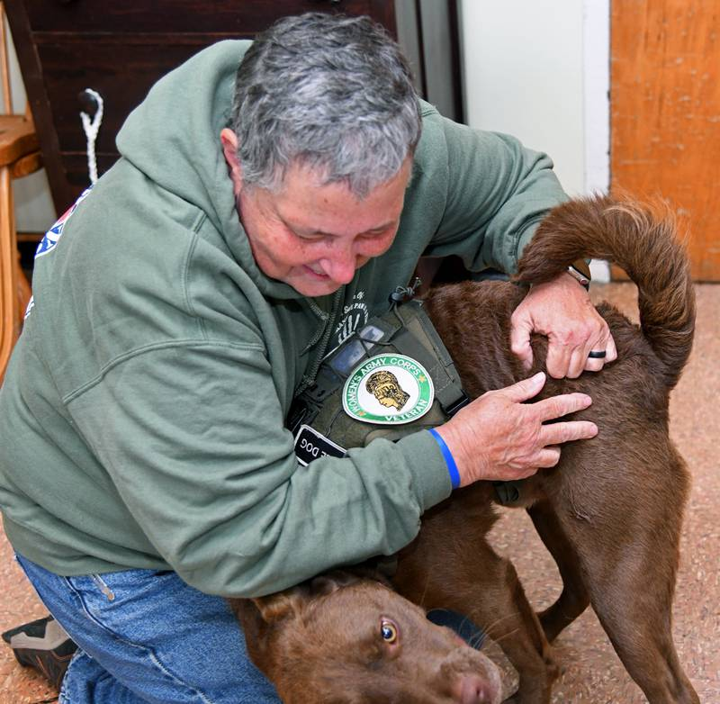

Sam Landis, an Army veteran who has PTSD, shares a playful moment with her service dog, Bodhi, at U.S. Kennels Inc. in Salisbury. (Barbara Haddock Taylor/Baltimore Sun)

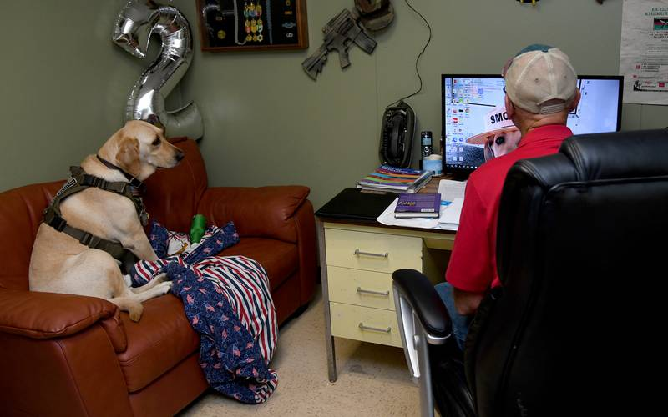

Gus, a service dog who belongs to U.S. Army veteran Danray Atkinson, right, relaxes in Atkinson's office at U.S. Kennels Inc. in Salisbury. (Barbara Haddock Taylor/Baltimore Sun)

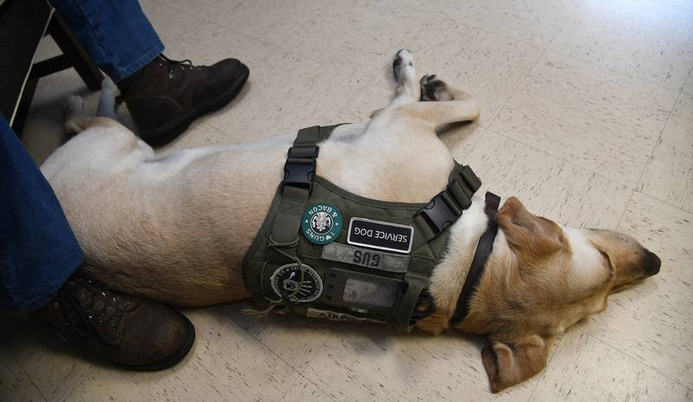

Gus, a service dog who belongs to Army veteran Danray Atkinson, rests between Atkinson's feet at U.S. Kennels Inc. Atkinson is a volunteer and the lead trainer at the nonprofit organization in Salisbury, and Gus is the program's first graduate. (Barbara Haddock Taylor/Baltimore Sun)

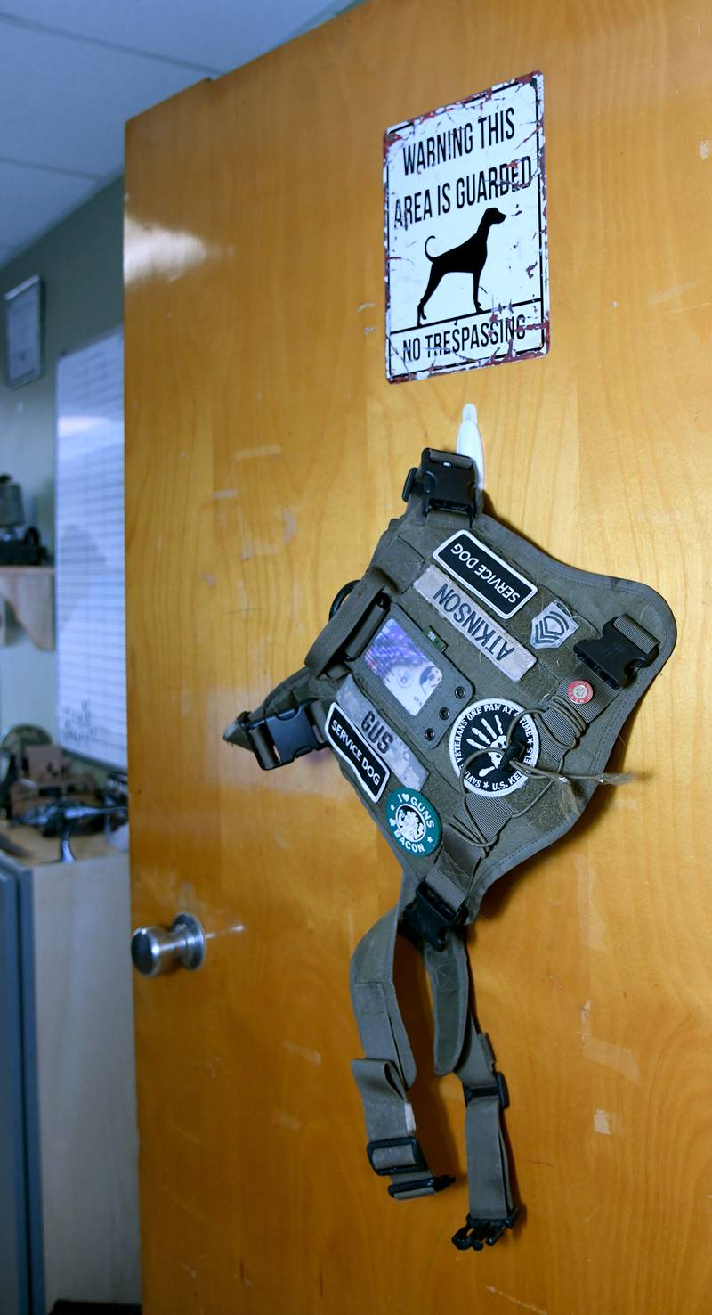

Service dog Gus' working vest hangs on the office door of his owner, Army veteran Danray Atkinson, at U.S. Kennels Inc. When the vest is hanging on the door, that means Gus is having a break. Otherwise, he never leaves Atkinson's side and helps him cope with PTSD. (Barbara Haddock Taylor/Baltimore Sun)

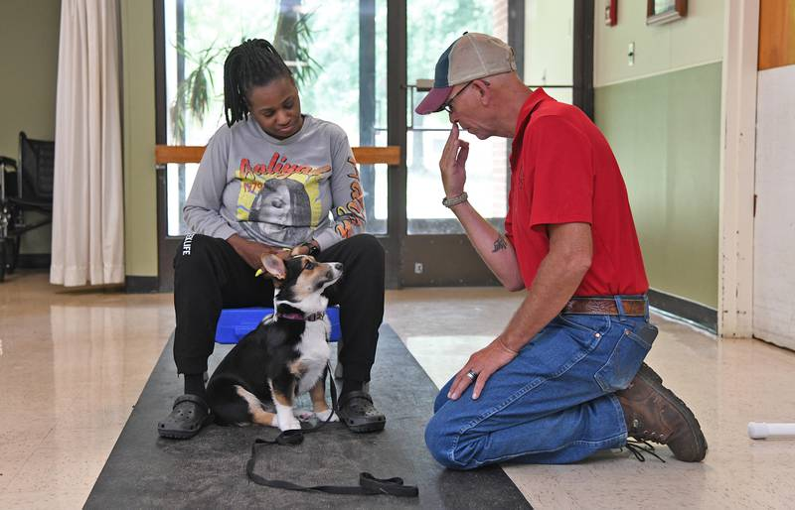

Nycole Beck of Salisbury and her service dog, Duke, learn an eye contact behavior from lead trainer Danray Atkinson at U.S. Kennels Inc. (Barbara Haddock Taylor/Baltimore Sun)

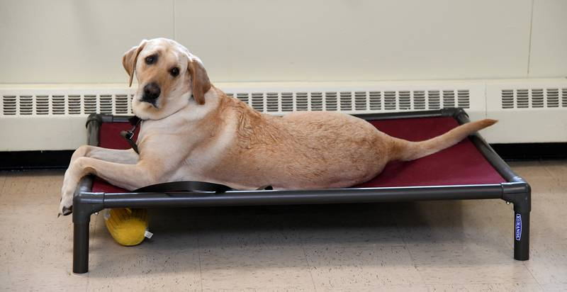

Gus, a service dog who belongs to Army veteran Danray Atkinson, keeps an eye on his master as he trains another dog at U.S. Kennels Inc. (Barbara Haddock Taylor/Baltimore Sun)

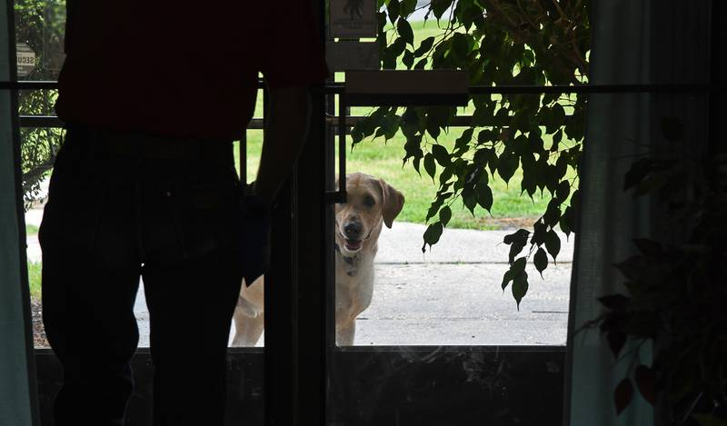

Gus, a service dog, waits at the door after a bathroom break at U.S. Kennels Inc., a nonprofit organization on Maryland's Eastern Shore. It rescues dogs from shelters and trains them to become service dogs for veterans. (Barbara Haddock Taylor/Baltimore Sun)

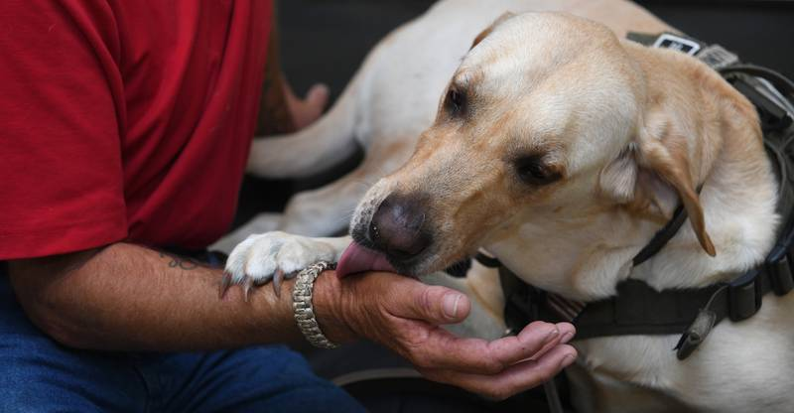
Gus, a service dog who belongs to Army veteran Danray Atkinson, demonstrates a calming behavior. Atkinson is the lead trainer at U.S. Kennels Inc. in Salisbury. (Barbara Haddock Taylor/Baltimore Sun)

